**Docker Images and Containers Assignments:**

**01: Basic Image Creation  
   - Create a Docker image for a simple web application using a Dockerfile. Ensure it runs on port 80.**

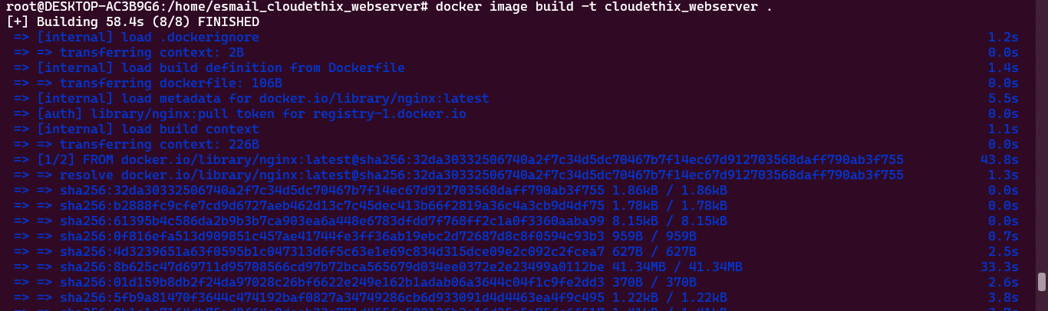



**02: Running Containers  
   - Run two containers from the same image concurrently. Configure each container to listen on different ports. Test their accessibility.**

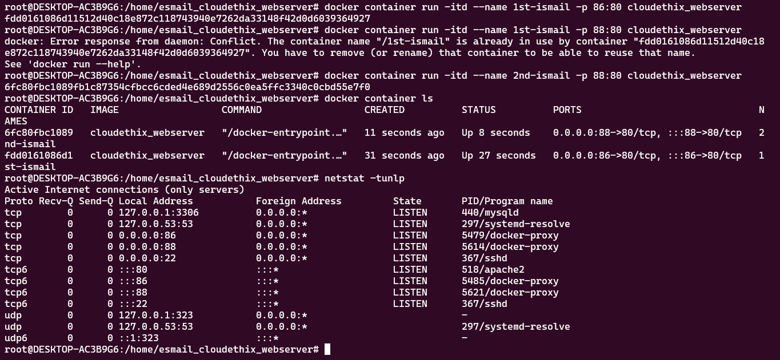

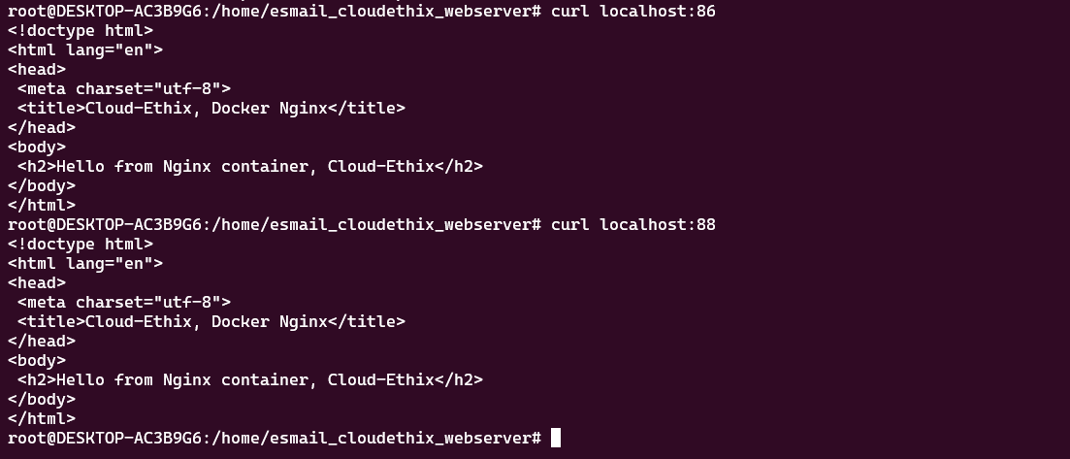





**03: Docker Compose  
   - Use Docker Compose to define and run a multi-container application. Include at least two services and establish communication between them.**

**04: Container Management (Restart Policies)   
   - Run some docker containers and test all the restart policies.**

**No policy**

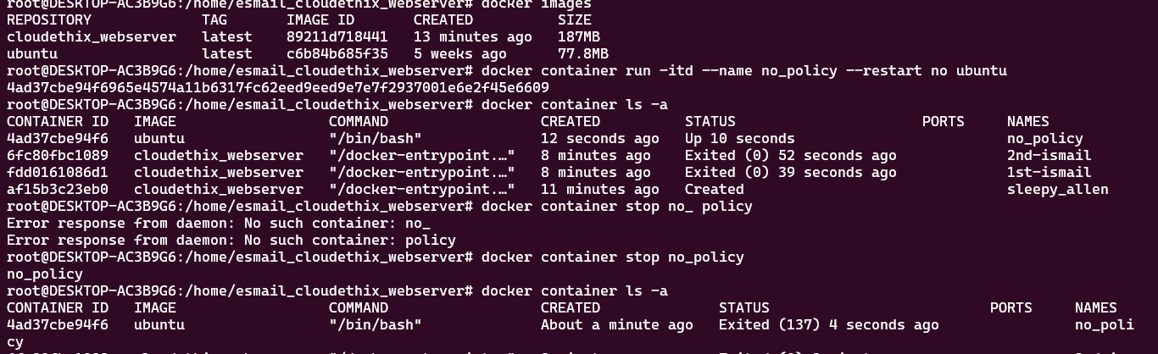

**on-failure policy**

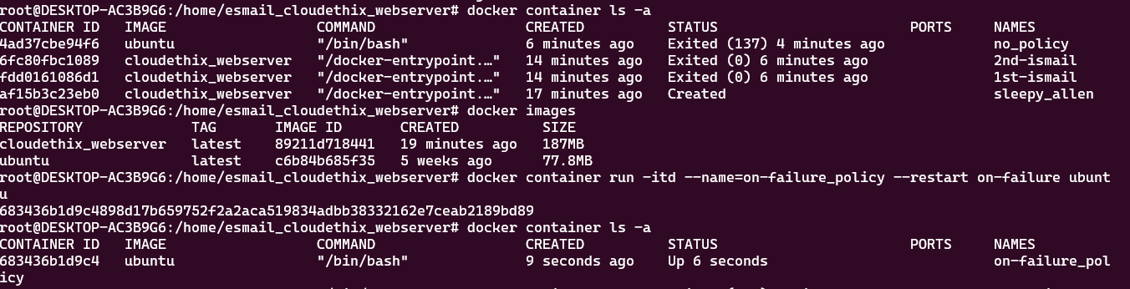

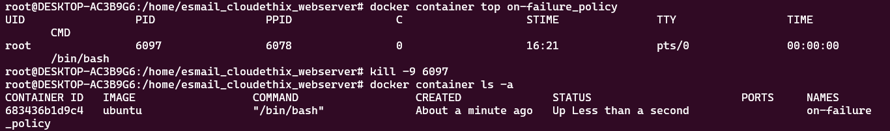

**always restart policy**

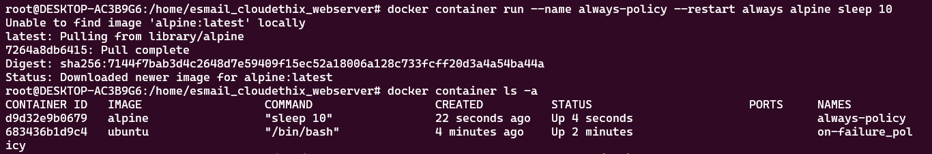



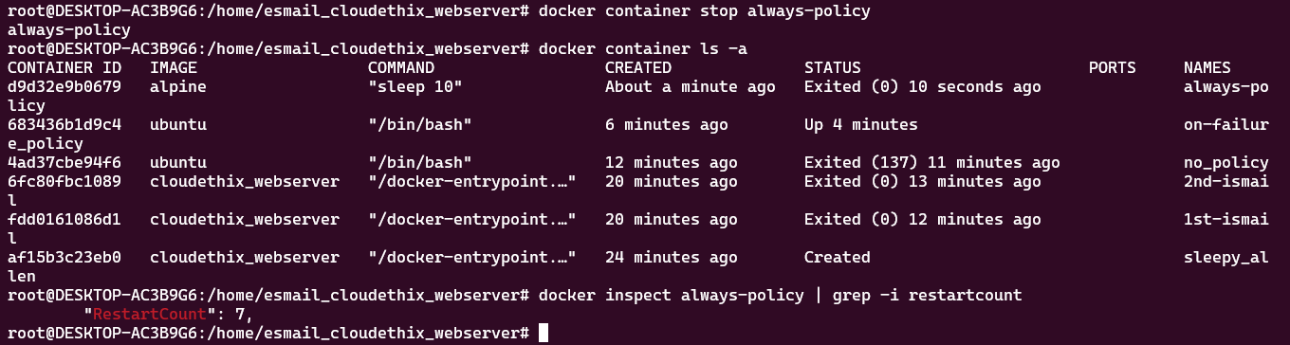

**unless-stopped policy**





**05: Docker Networks  
   - Create a custom Docker network and launch two containers within it. Verify that they can communicate with each other using container names.**

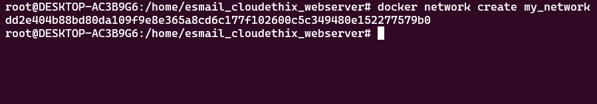



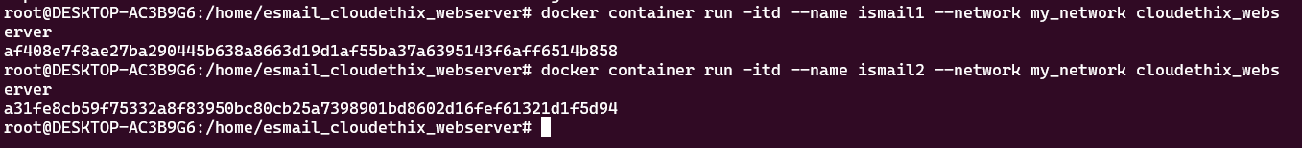

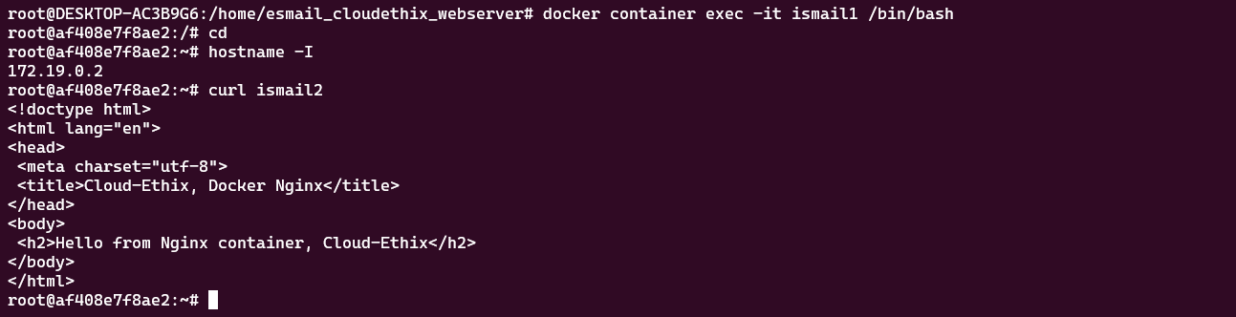

**: Create a network**

**# docker network create --driver bridge alpine-net**

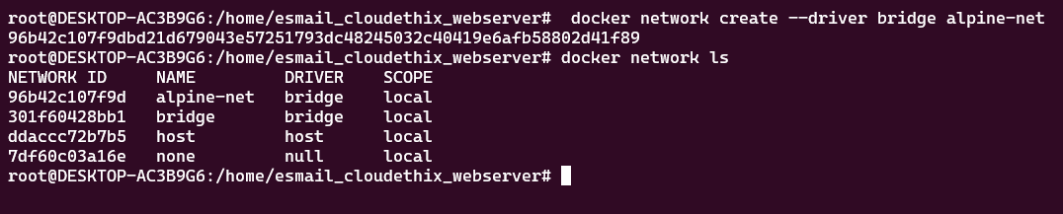



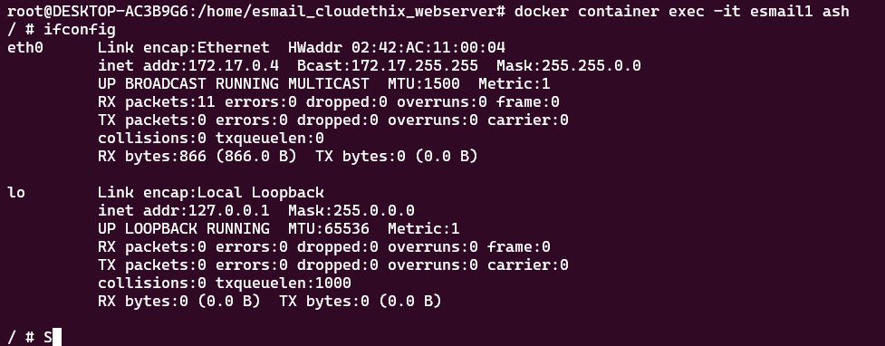

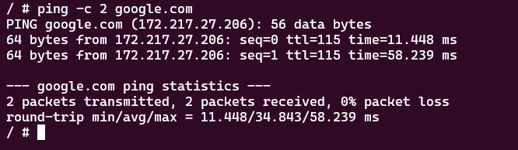

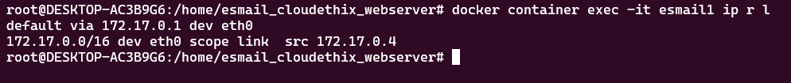

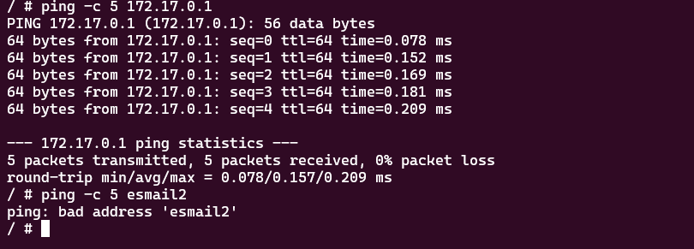

**06: Container Logging   
   - Configure a Docker container to write its logs to an external file on the host system. Retrieve and analyze the container's logs.**

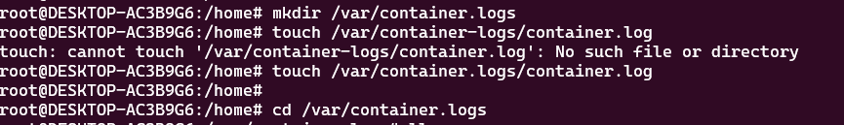

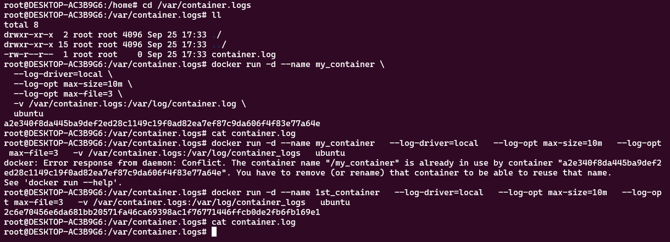

**07: Docker Registry  
   - Set up a private Docker registry and push a custom Docker image to it. Then, pull the image from the registry and run containers.**

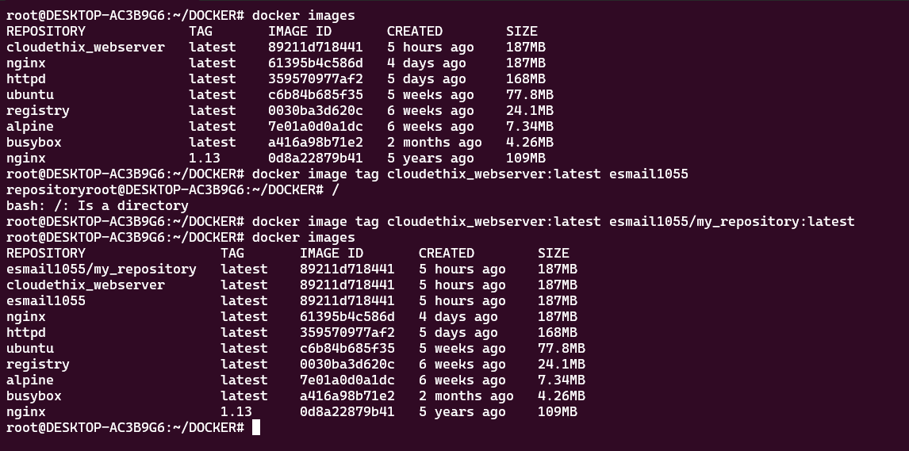

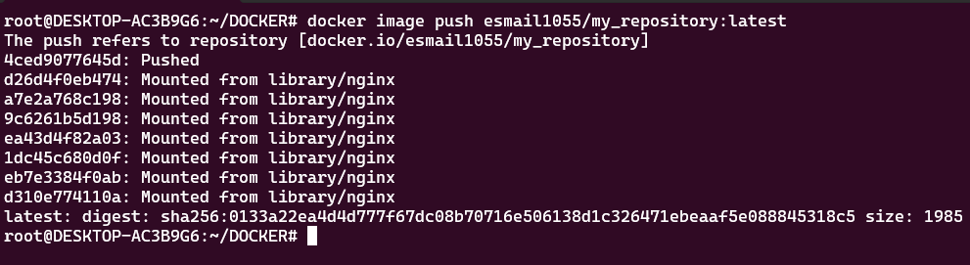

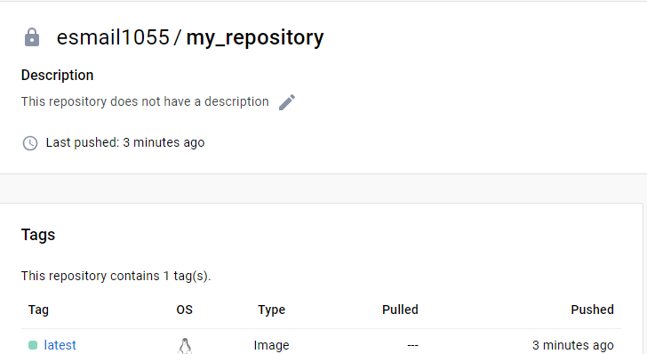

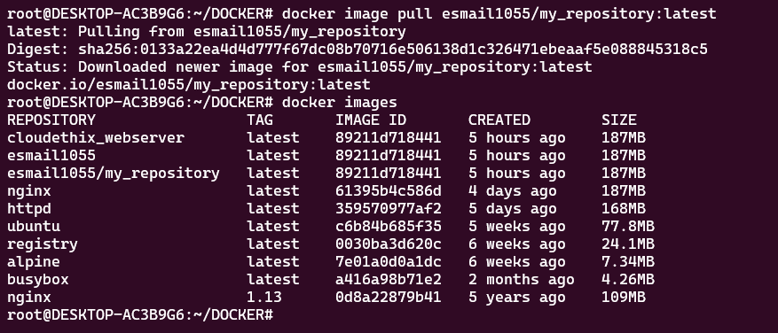



**08: Docker Health Checks  
   - Create a Dockerfile for a service that includes health checks. Implement custom health checks and verify the container's health status.**

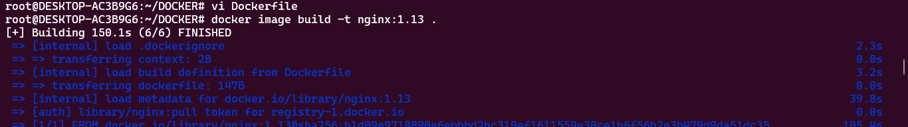

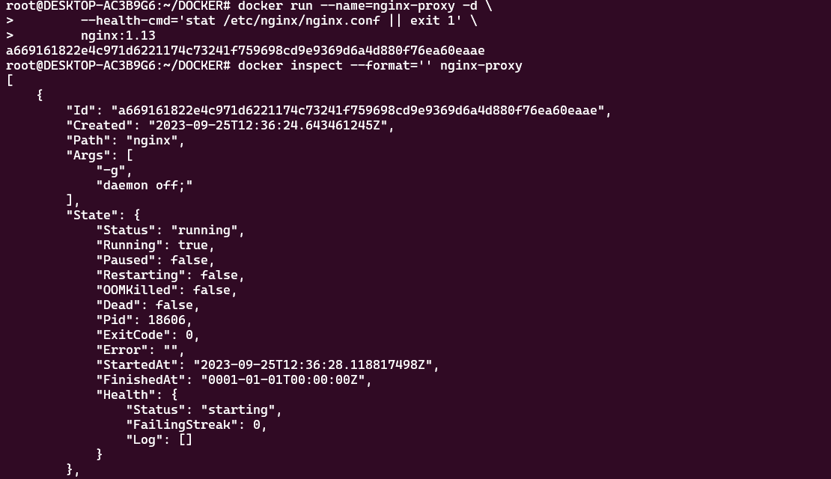



1. **Create a Docker volume and use it to persist data generated by a running container. Demonstrate data persistence across container restarts.**

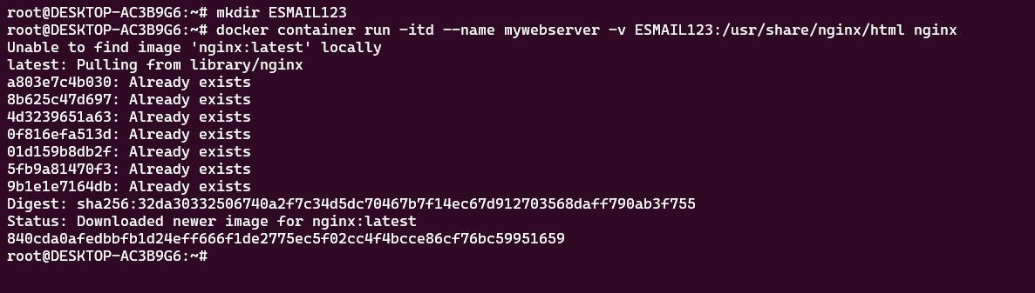



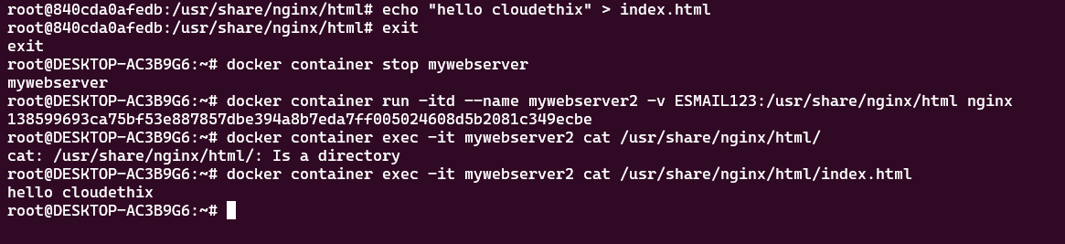

**10: Bind Mounts  
   - Configure a Docker container to use a bind mount to access files from the host system. Modify files on the host and observe the changes within the container**

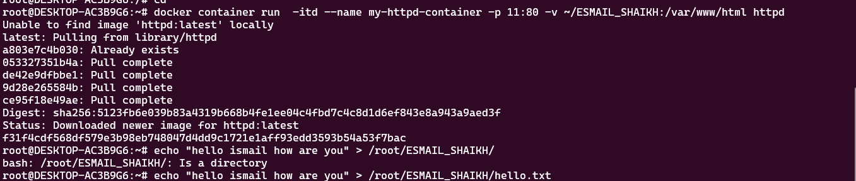



**.**

**11: Docker Networking Modes  
   - Experiment with different Docker networking modes (bridge, host, overlay) and explain their use cases and differences.**

### Creating Networks

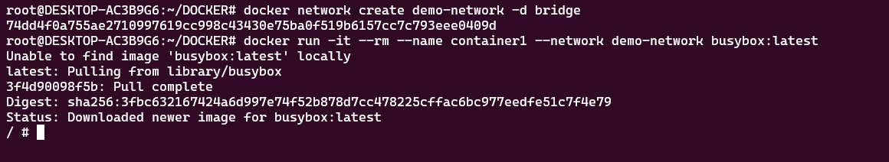

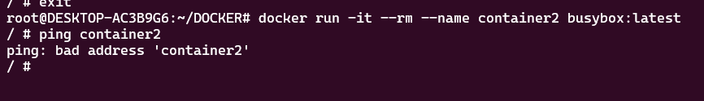

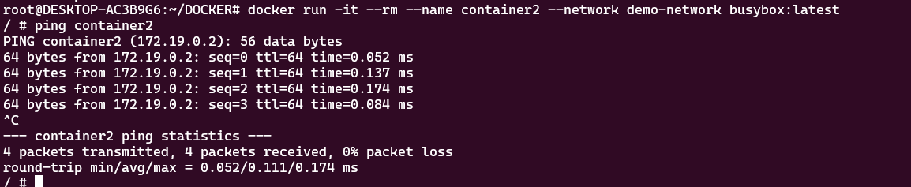

### Using Host Networking

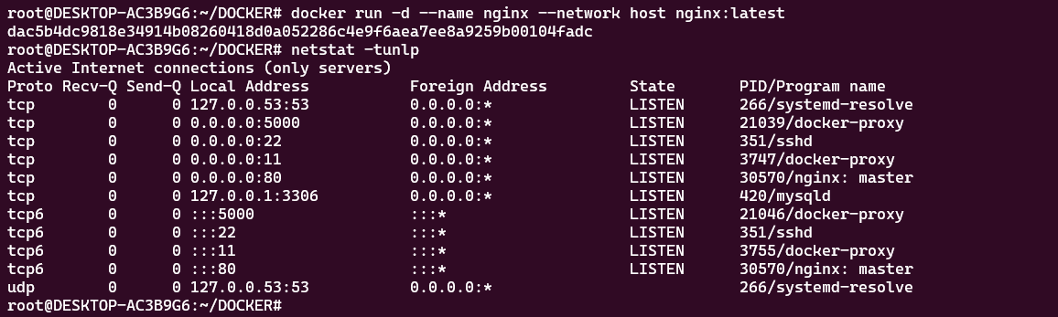

**12: Container Networking  
   - Create a custom Docker network and deploy a multi-container application where each container serves a unique purpose and communicates effectively.**

